Application Deployment
(Deploy the given React application to a production ready state)

Application:
Clone the below mentioned repository and deploy the application (Run application in port 3000).
Repo URL : https://github.com/Vennilavanguvi/Trend.git

Docker:
- Dockerize the application by creating Dockerfile
- Build an application and check output using docker image.

Terraform:
- Define infrastructure in main.tf to create VPC, IAM, EC2 with Jenkins, etc.
- Use terraform command to provision infrastructure.
DockerHub:
- Create a DockerHub repository.
Kubernetes:
- Setup Kubernetes in AWS EKS and Confirm EKS cluster is running.
- Write deployment and service YAML files.
- Deploy using kubectl via Jenkins.
Version Control:
- Push the codebase to a Git provider (GitHub).
- Add gitignore and dockerignore files and use CLI commands to push code.
Jenkins:
- Install Jenkins and necessary plugins (Docker, Git, Kubernetes, Pipeline) for build, push &deploy applications.
- Setup Github and jenkins integration using github webhook build trigger for auto build for every commit.
- Create a declarative pipeline script and pipeline project to build, push & deploy using CI-CD.

Monitoring:
- Setup a monitoring system to check the health of the cluster or application (opensource) is highly appreciable.
Submission Guidelines:
- GitHub Link: Submit full code repository.
- README File: Include setup instructions, pipeline explanation, and screenshots or create a document and attach all screenshots.
- Application deployed kubernetes Loadbalancer ARN.

Ckecking in Local:
git clone https://github.com/Vennilavanguvi/Trend.git
cd Trend/dist
python3 -m http.server 3000

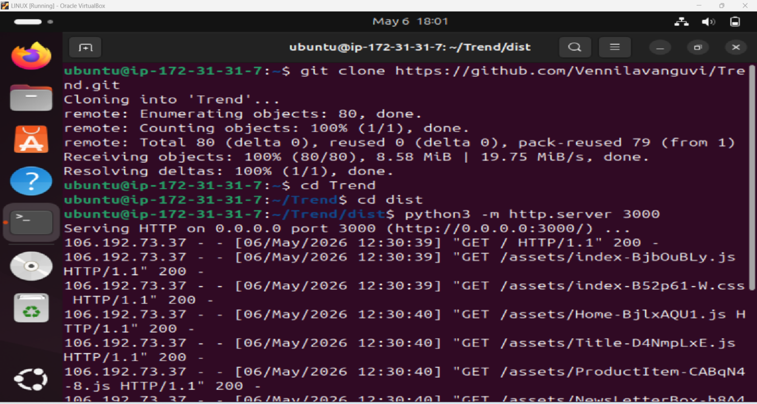

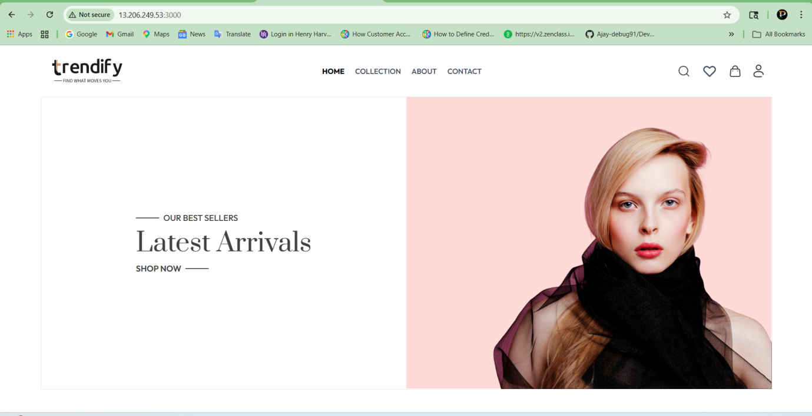

Dockerization:

Create Dockerfile in The App Location
sudo apt update
sudo apt install docker.io
sudo systemctl start docker
sudo systemctl enable docker
sudo systemctl status docker
python3 -m http.server 3000
sudo usermod -aG docker ubuntu
newgrp docker
vi Dockerfile

docker build -t trend-app .
docker run -d -p 3000:80 trend-app

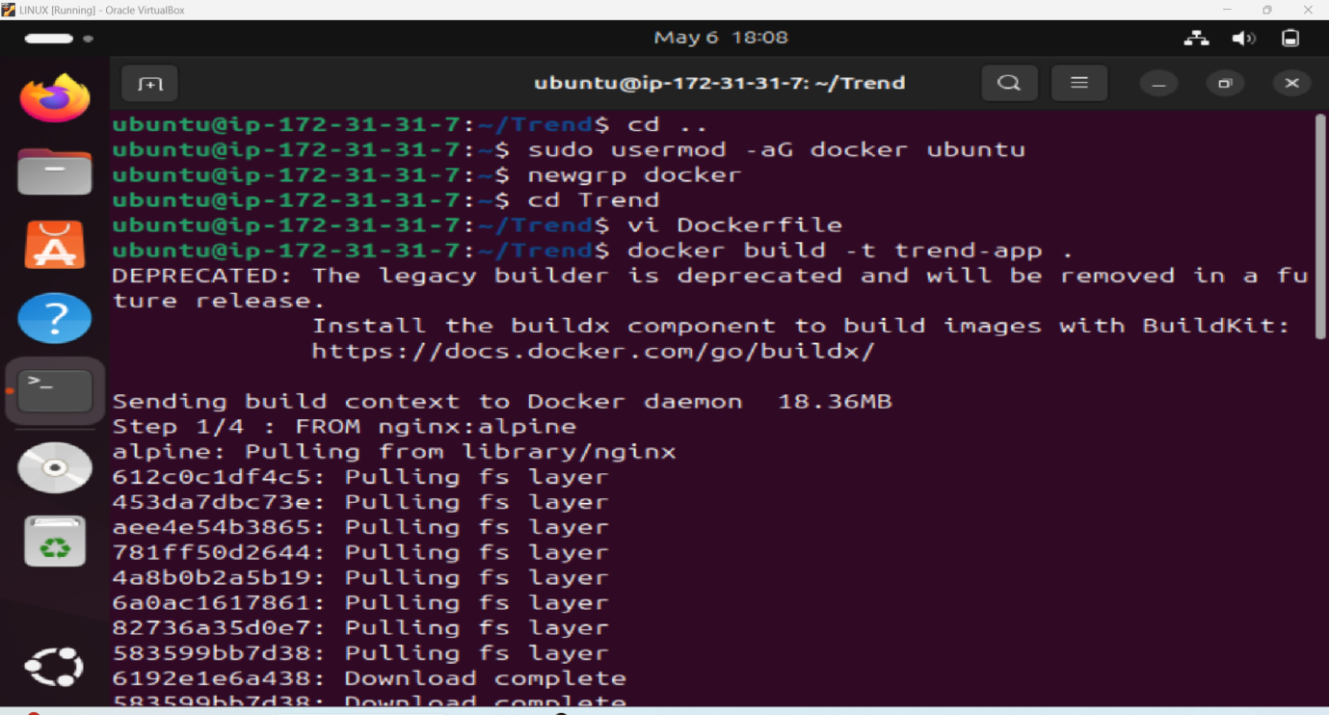

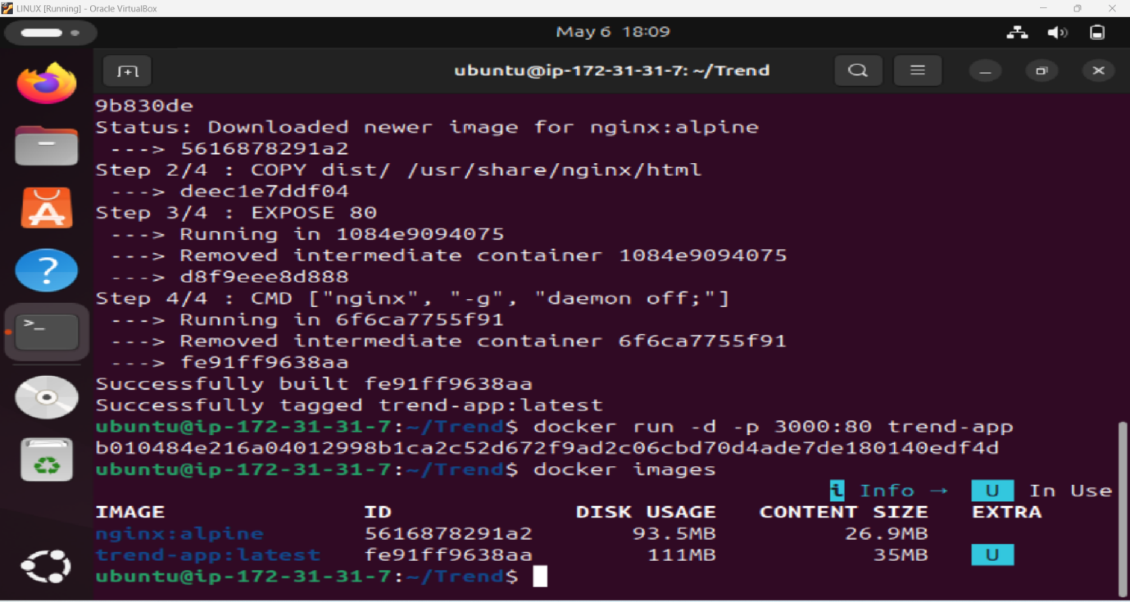

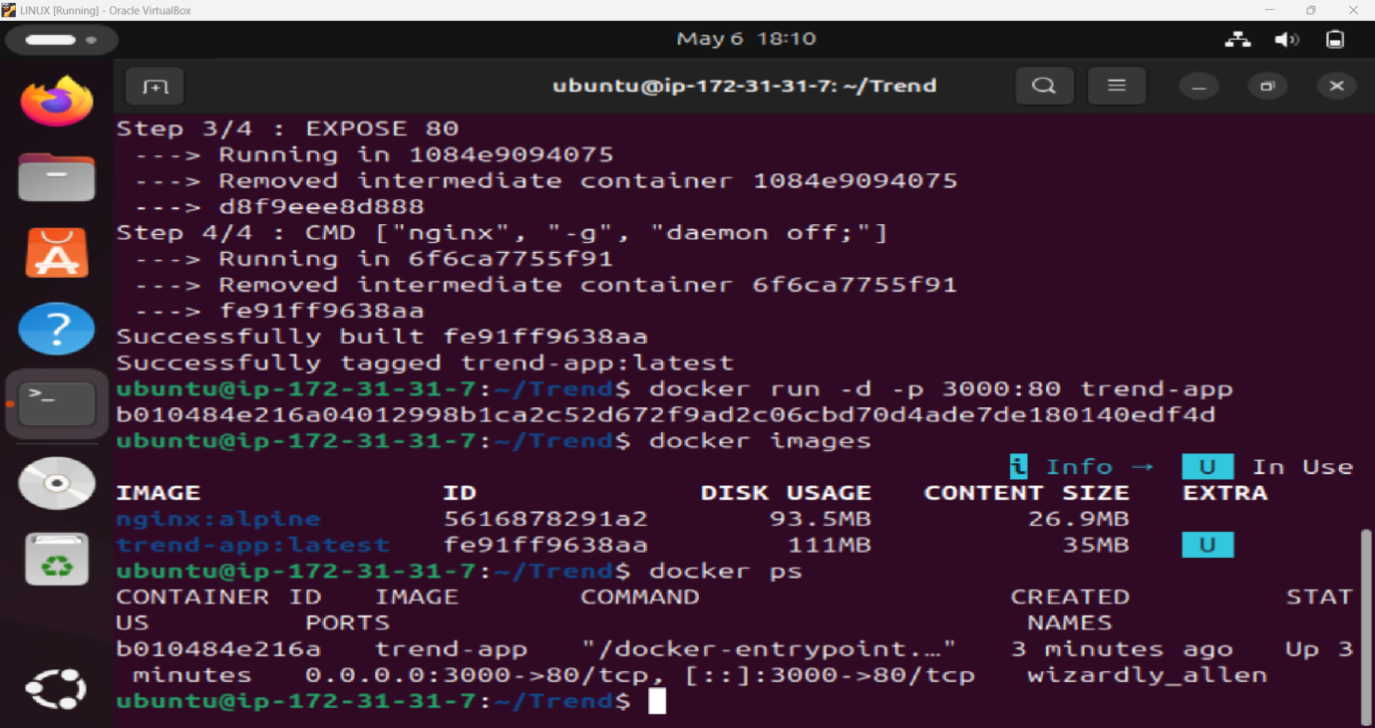

Push Image To DockerHub:

docker login

docker tag trend-app dprakash4a3/trend-app
docker push dprakash4a3/trend-app
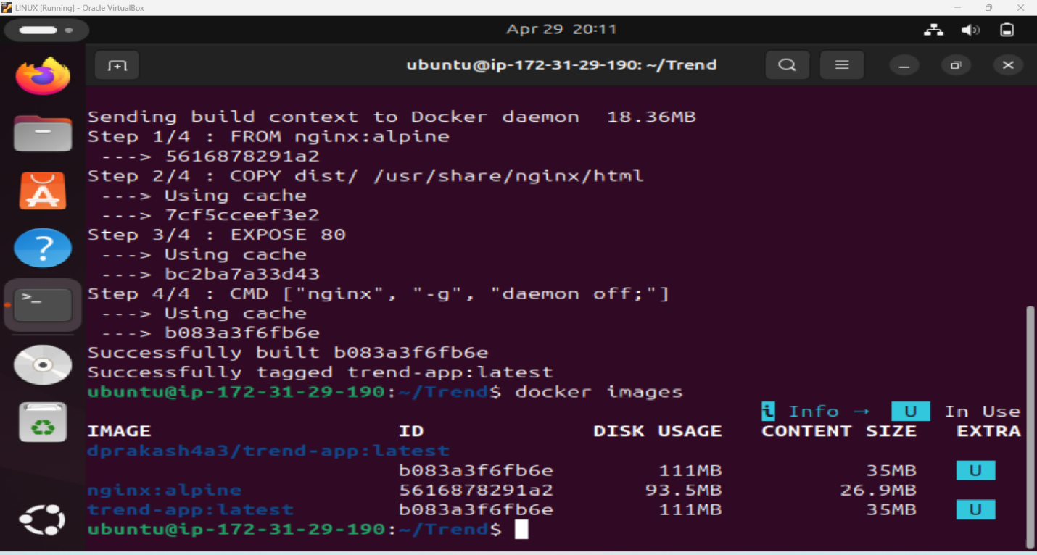

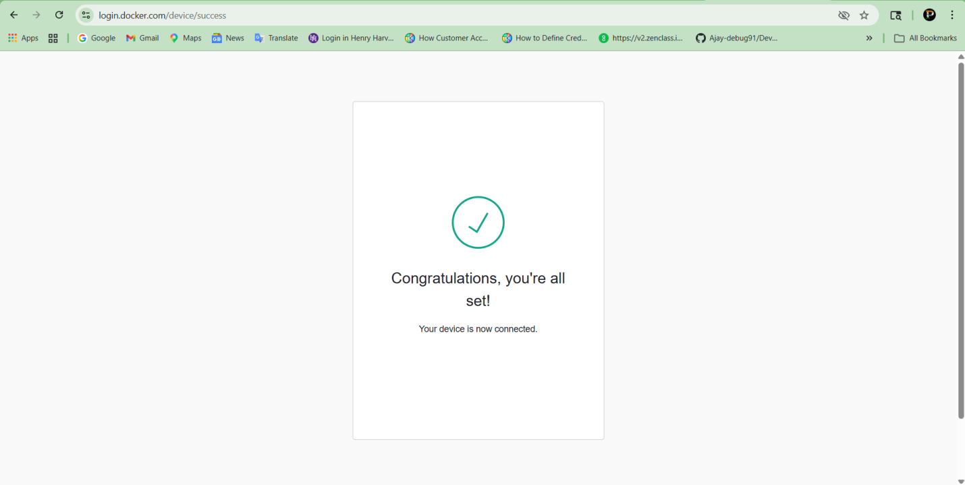

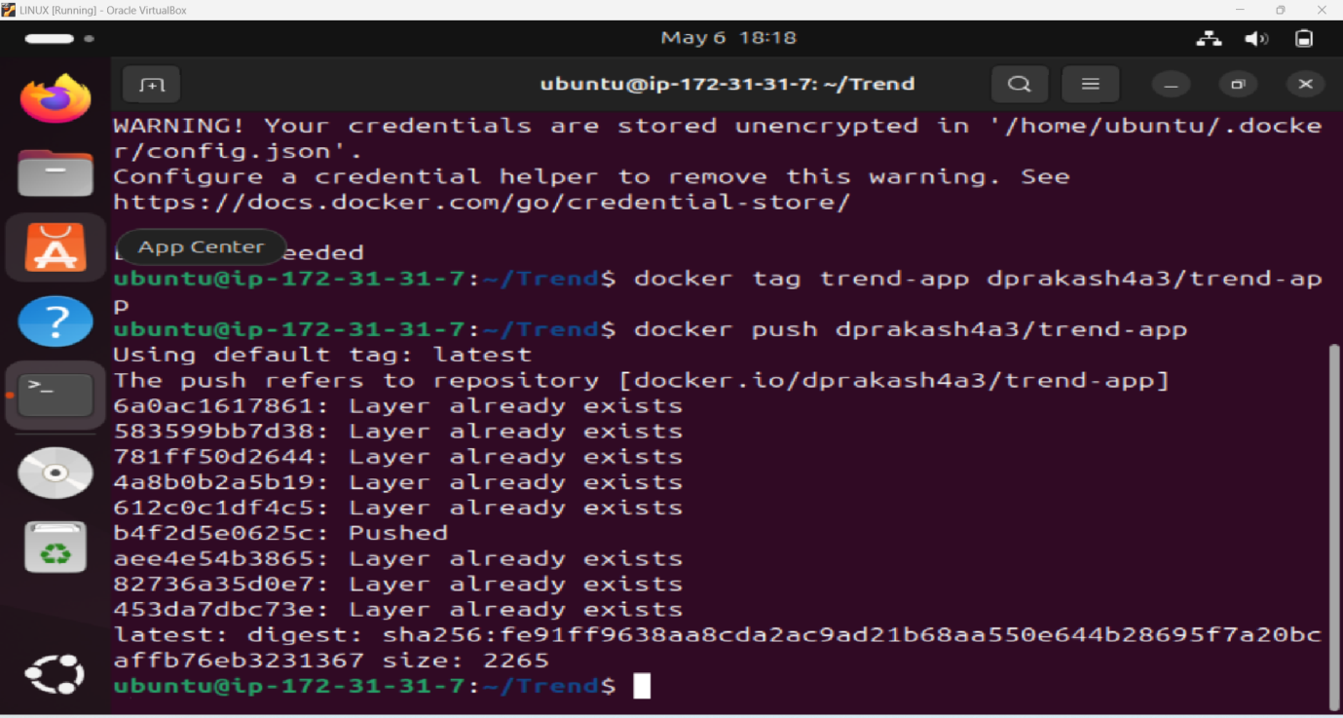

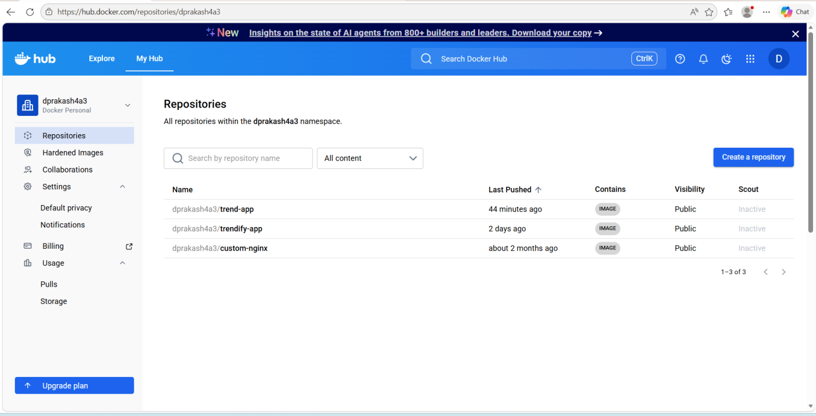

Install AWS And Configure:
sudo apt update
sudo apt install unzip
curl "https://awscli.amazonaws.com/awscli-exe-linux-x86_64.zip" -o "awscliv2.zip"
unzip awscliv2
sudo ./aws/install
aws --version

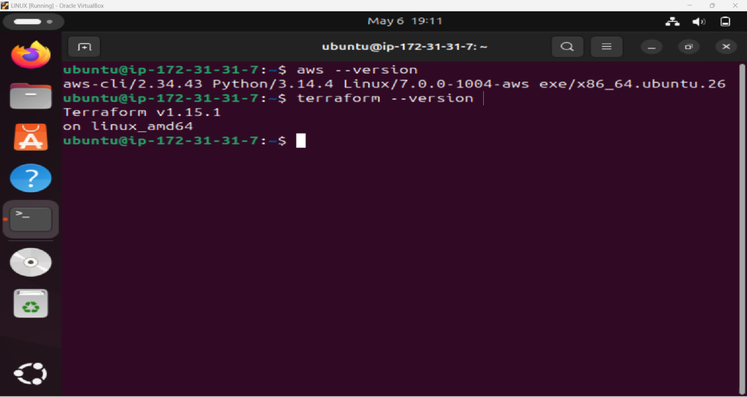

AWS Configure:
aws configure
access key:
Secret Acces Key:
Default Region:
Default output Format:

Install Terraform:
curl -O https://releases.hashicorp.com/terraform/1.15.1/terraform_1.15.1_linux_amd64.zip
sudo apt install unzip
sudo unzip terraform_1.15.1_linux_amd64.zip
sudo rm –rf terraform /usr/local/bin/
sudo mv terraform /usr/local/bin/
terraform --version

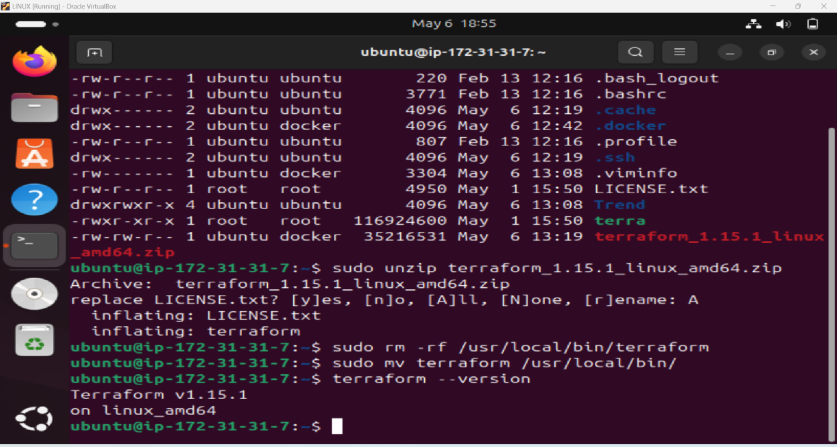

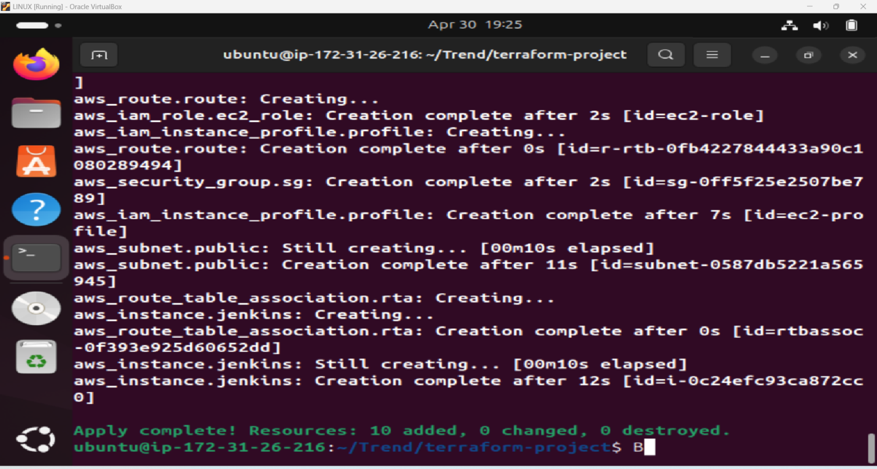

Install Jenkins:
sudo apt update
sudo apt install fontconfig openjdk-21-jre
java --version

sudo wget -O /etc/apt/keyrings/jenkins-keyring.asc \
https://pkg.jenkins.io/debian-stable/jenkins.io-2026.key
echo "deb [signed-by=/etc/apt/keyrings/jenkins-keyring.asc]" \
https://pkg.jenkins.io/debian-stable binary/ | sudo tee \
/etc/apt/sources.list.d/jenkins.list > /dev/null
sudo apt update
sudo apt install Jenkins

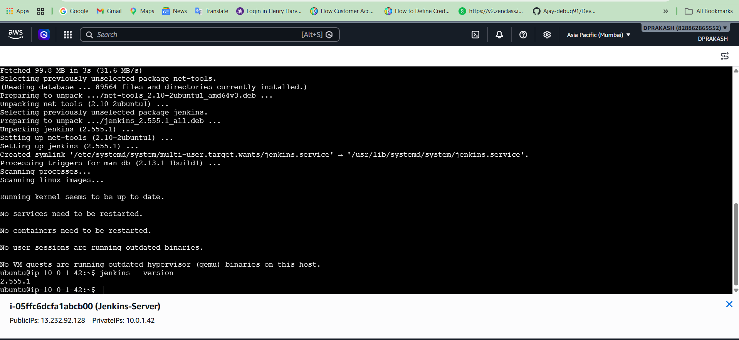



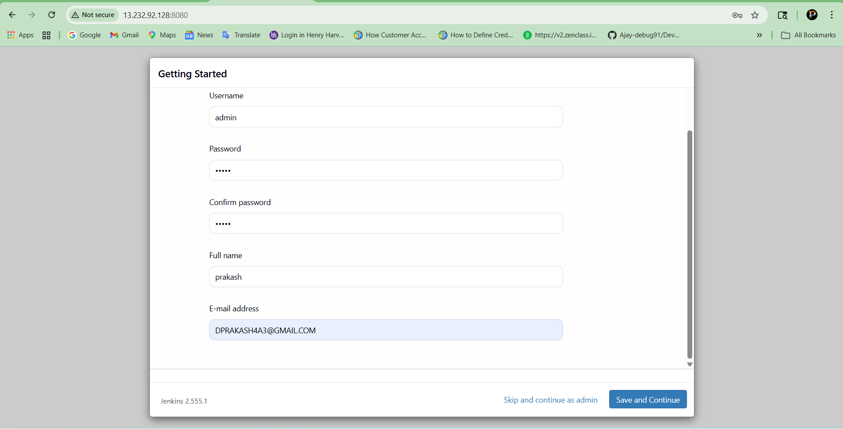

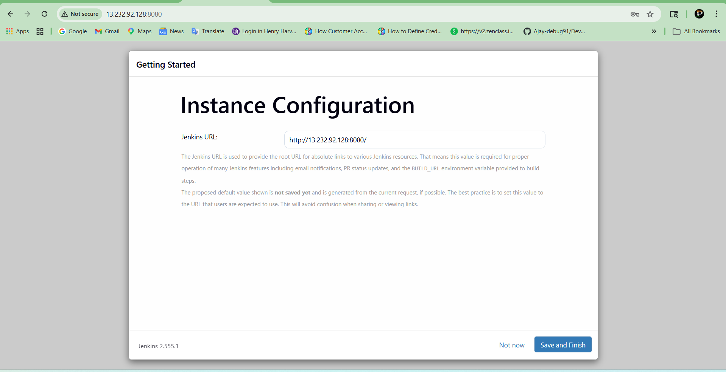

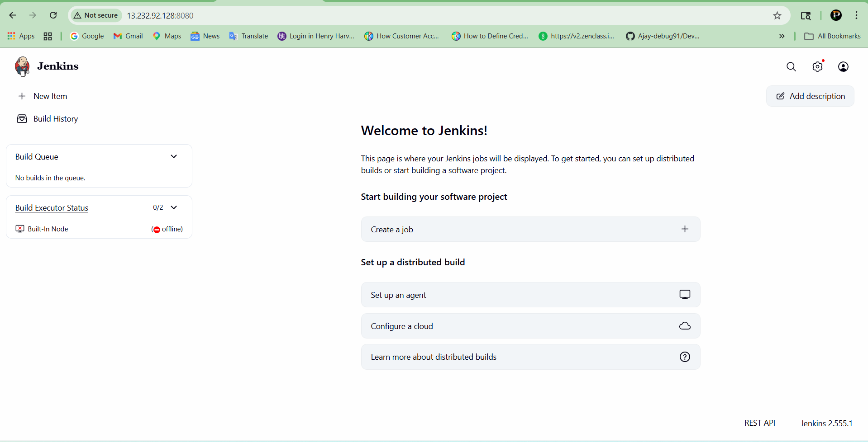

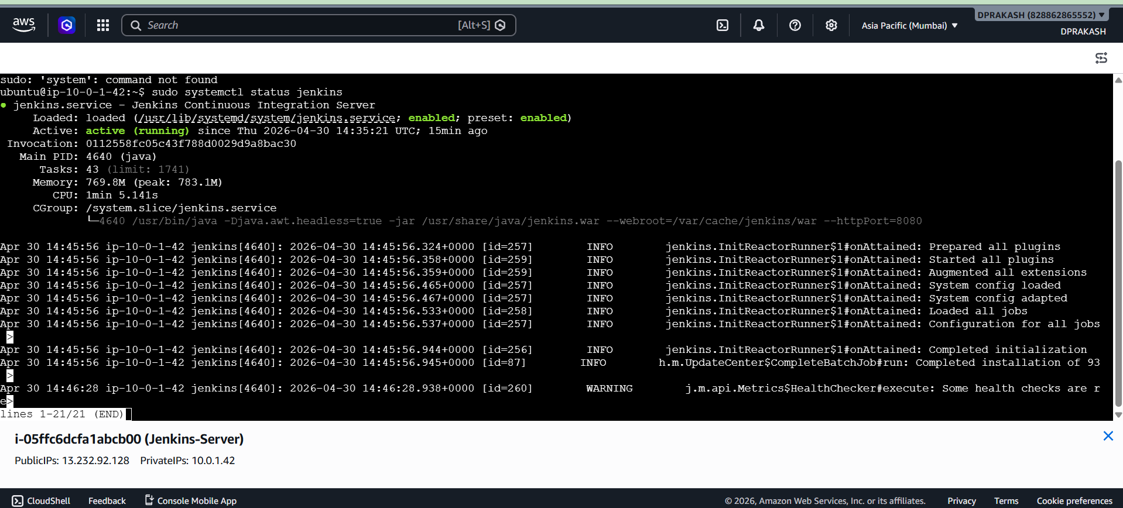

Push File To Github Repo
git init
Git add .
git commit -m "first commit"
git branch -M main
git remote add origin https://github.com/PrakashD189/TRENDIFY.git
git push -u origin main

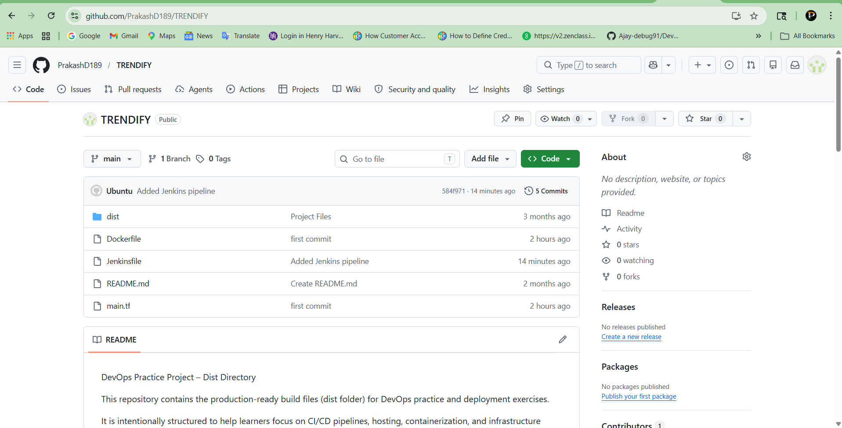

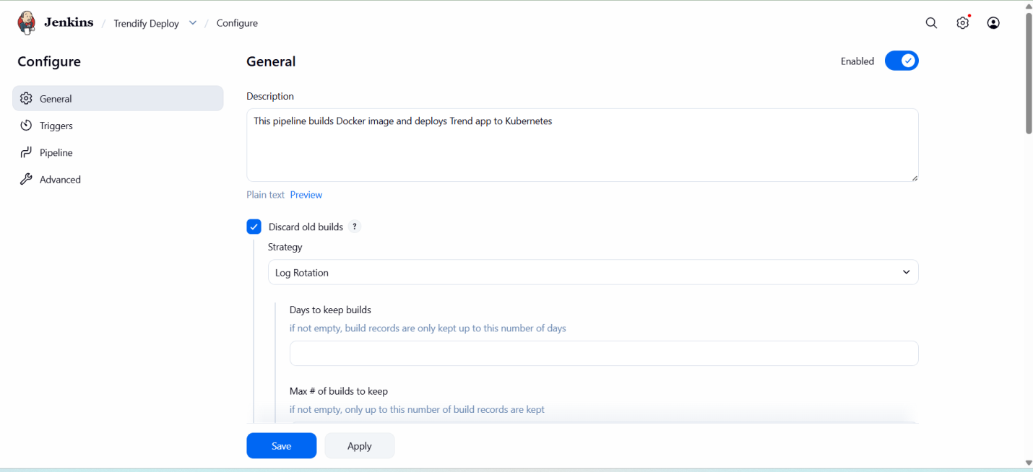

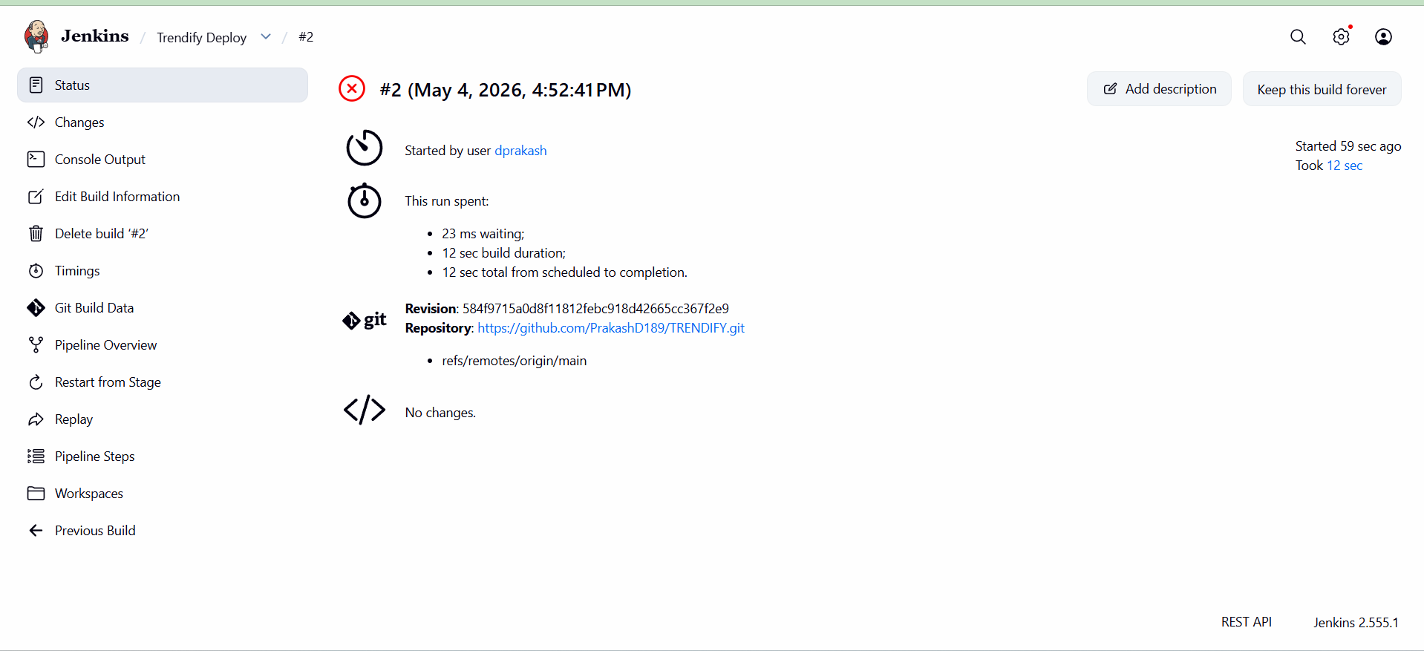

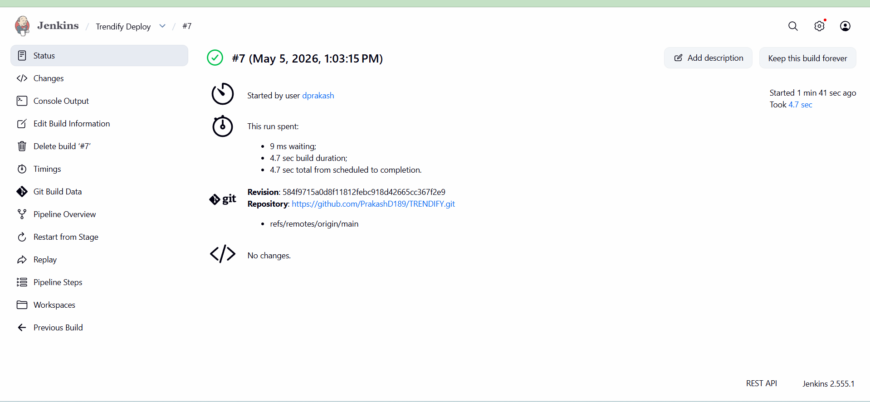

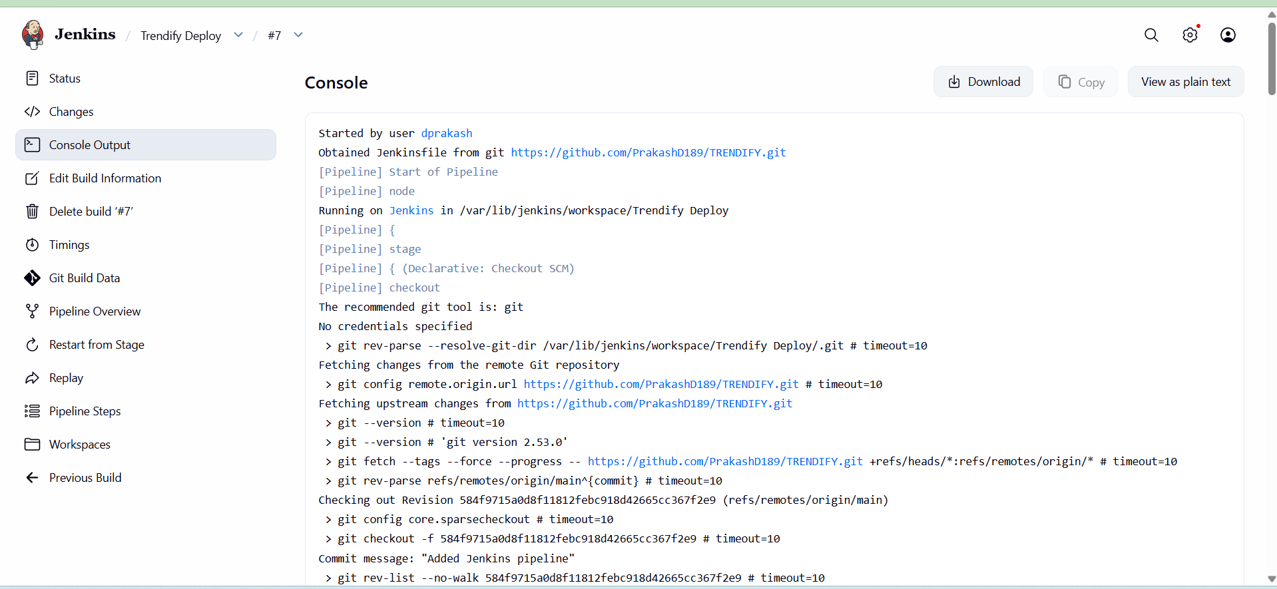

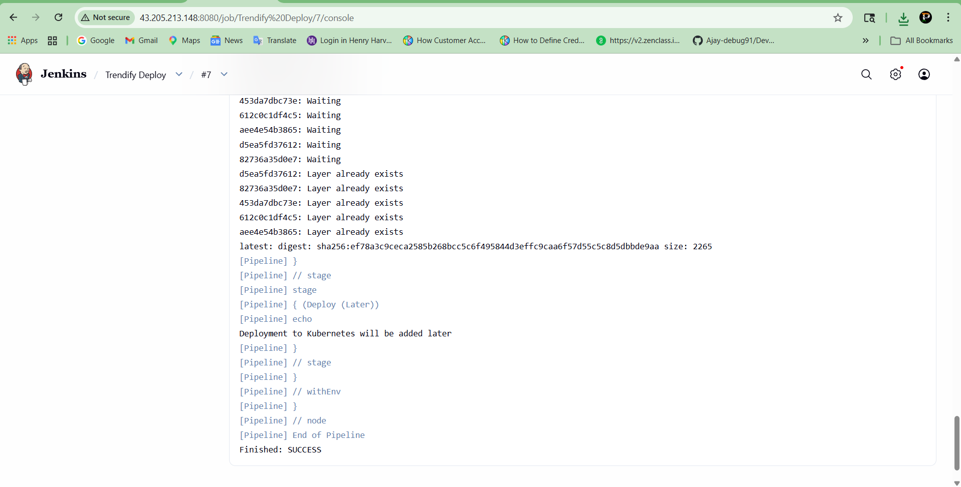

KUBERNETES DEPLOYMENT (EKS):
sudo apt update
sudo apt install -y awscli
Kubectl:
curl -o kubectl https://s3.us-west-2.amazonaws.com/amazon-eks/1.29.0/2024-01-04/bin/linux/amd64/kubectl
chmod +x kubectl
sudo mv kubectl /usr/local/bin/
kubectl version --client

Eksctl:

curl --silent --location "https://github.com/weaveworks/eksctl/releases/latest/download/eksctl_Linux_amd64.tar.gz" | tar xz -C /tmp
sudo mv /tmp/eksctl /usr/local/bin/
eksctl version

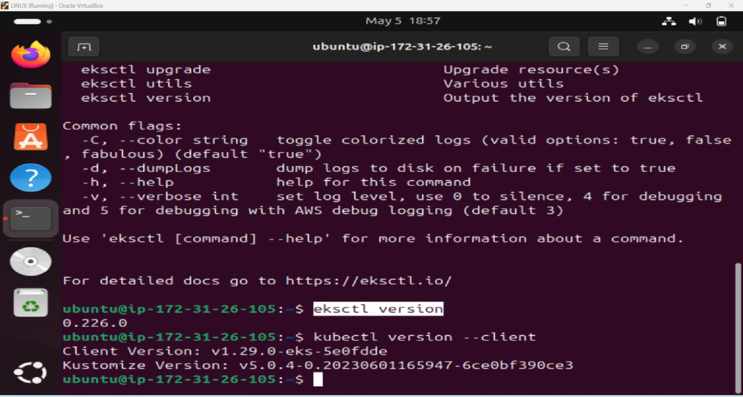

Configure AWS And Create Cluster

aws configure

eksctl create cluster \
--name trendify-cluster \
--region ap-south-1 \
--node-type t3.small \
--nodes 2

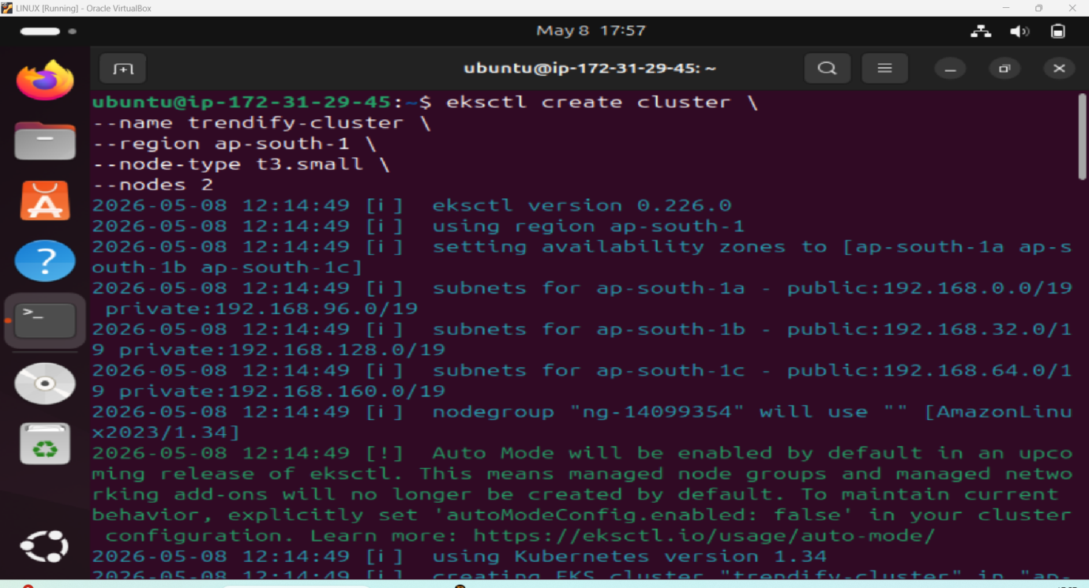

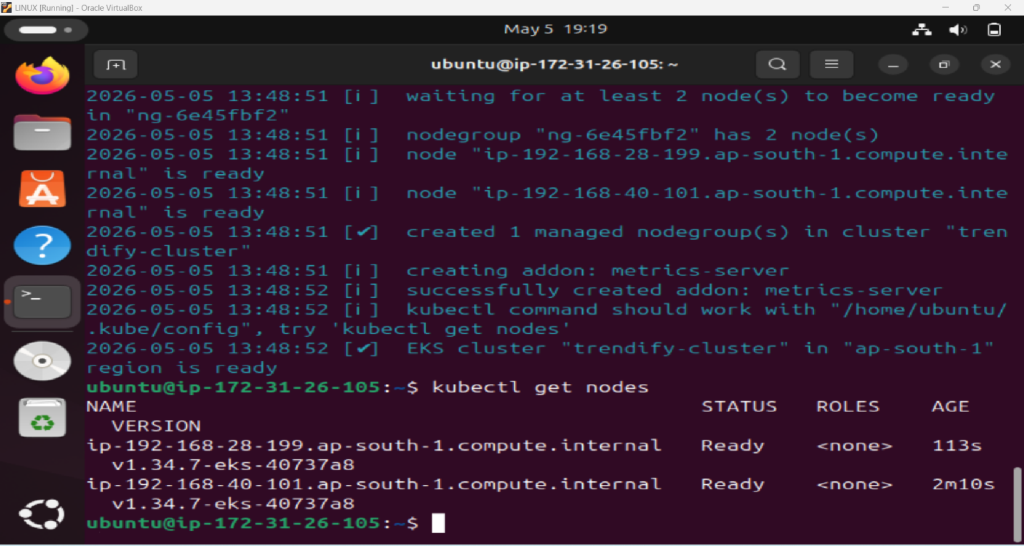

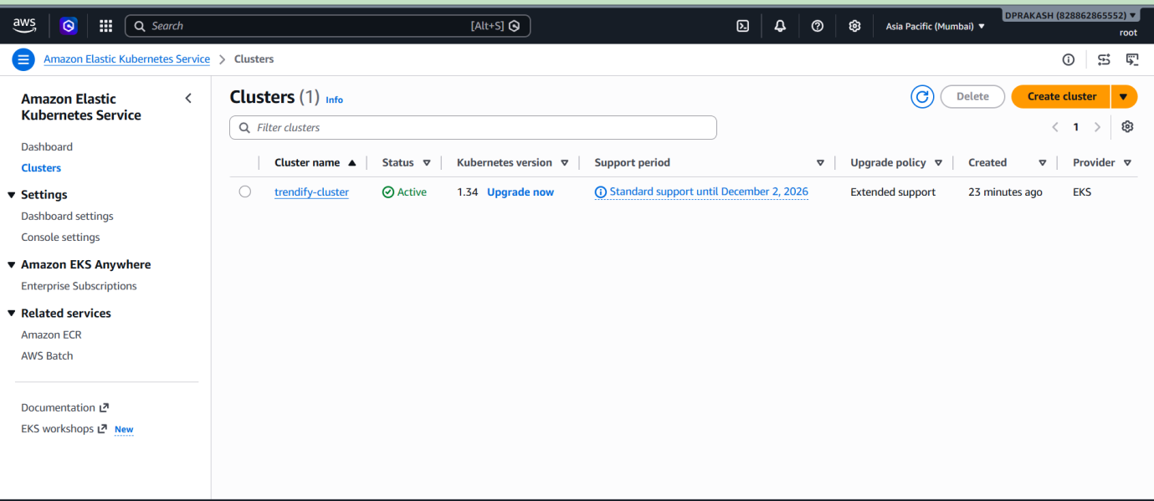

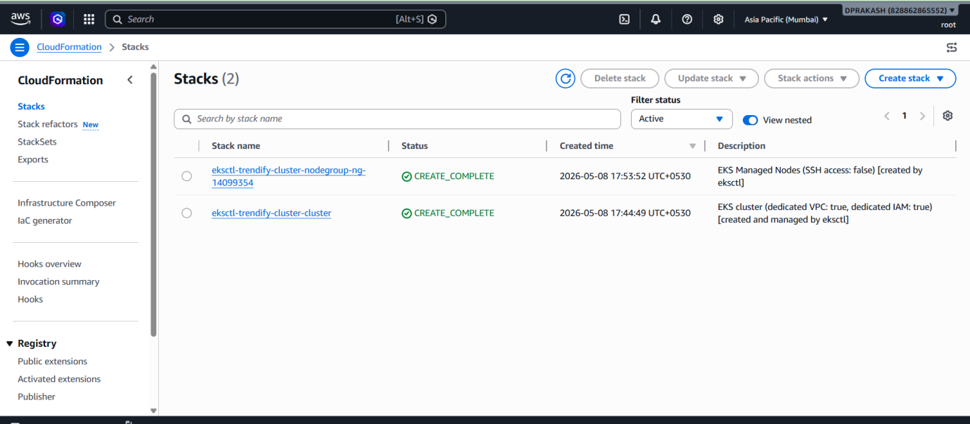

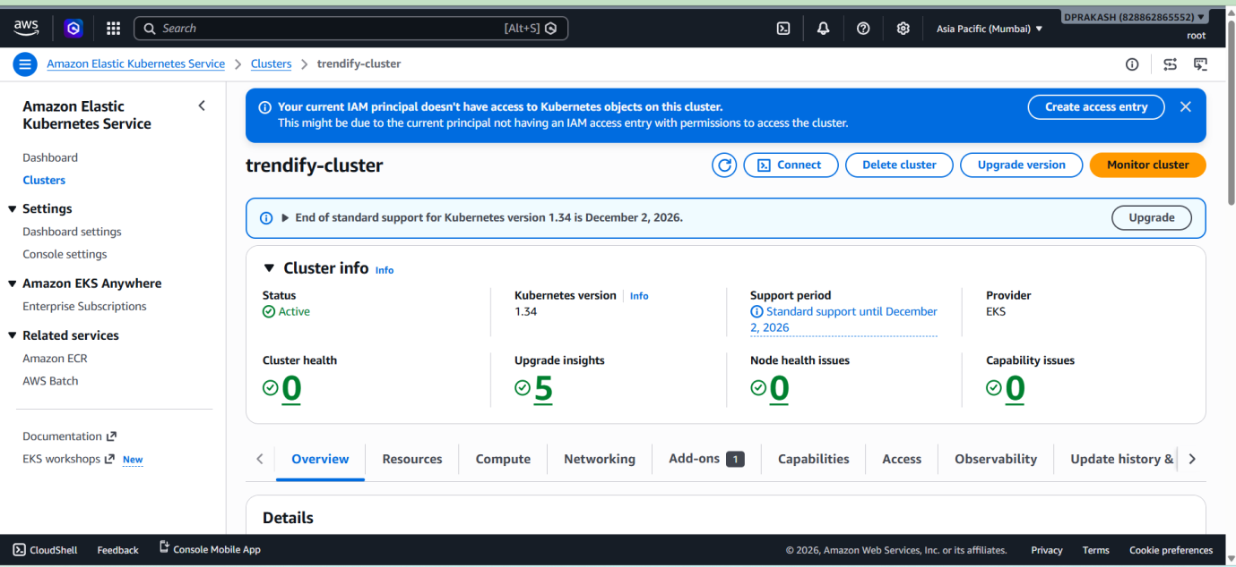

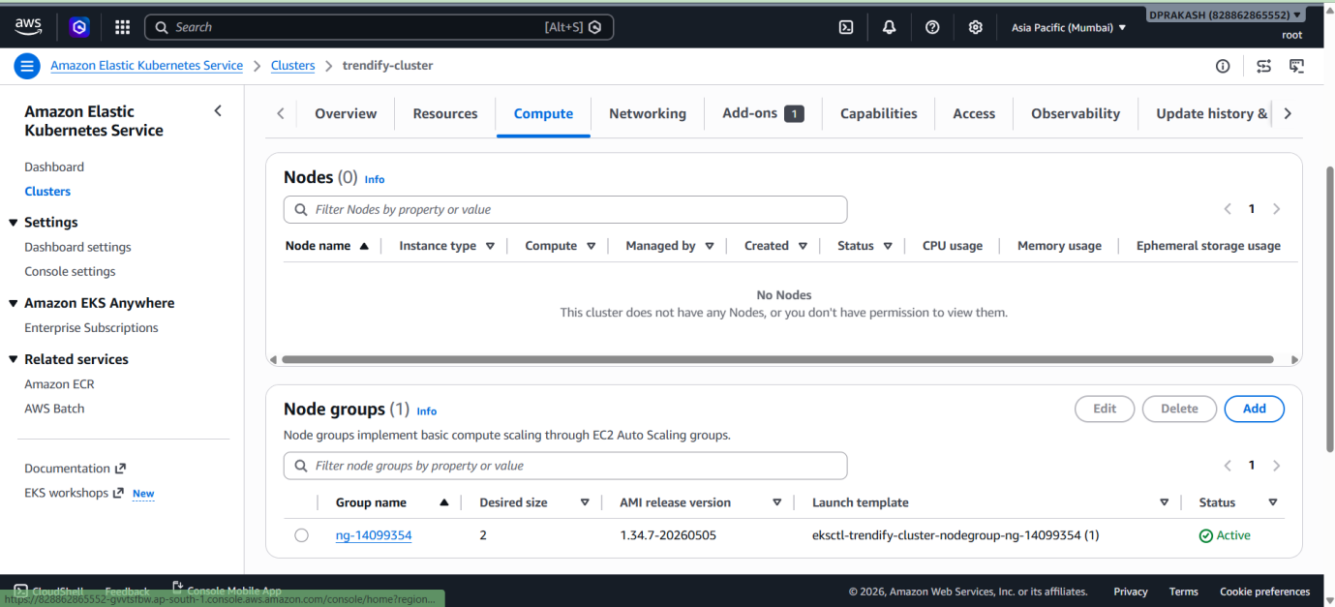



Deploy:
Create Deploment.yaml File And service.yaml File
vi deployment.yaml
vi service.yaml
kubectl apply -f deployment.yaml
kubectl apply -f service.yaml

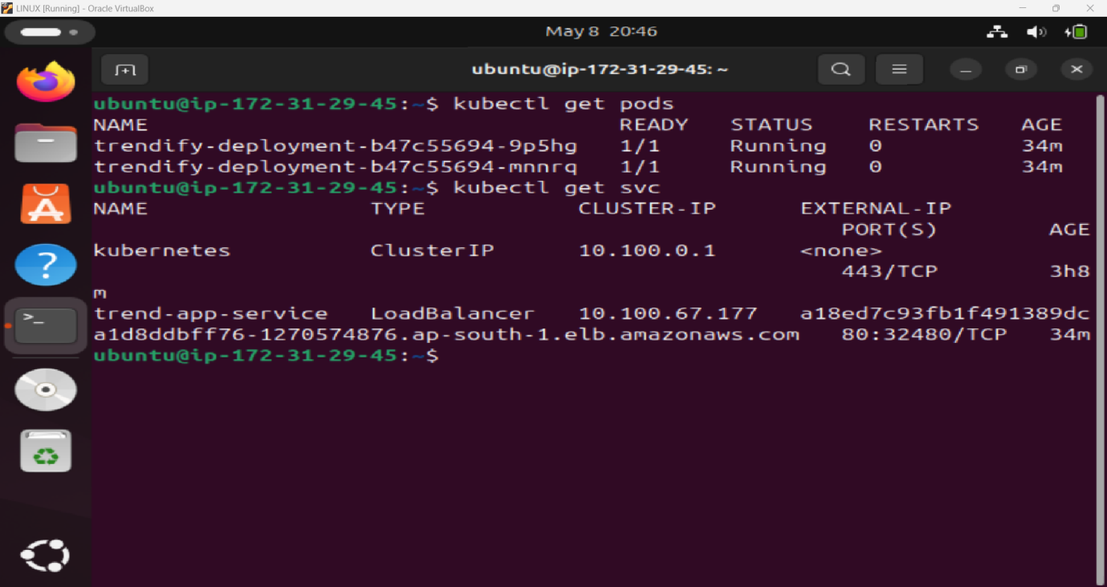

URL: http://a18ed7c93fb1f491389dca1d8ddbff76-1270574876.ap-south-1.elb.amazonaws.com/

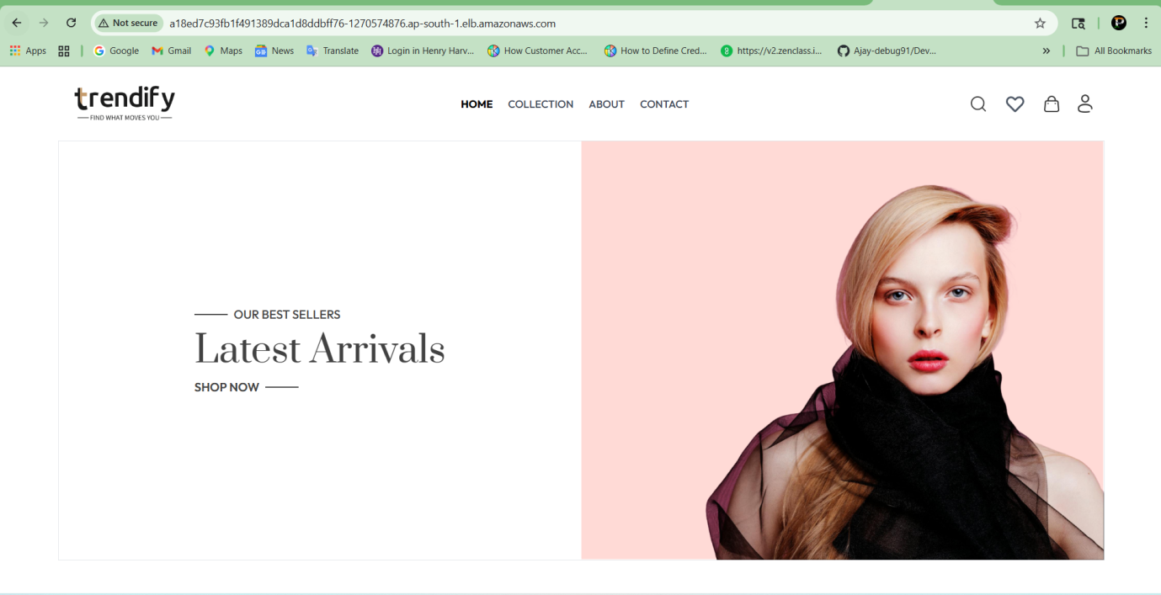

Monitoring Setup (Prometheus + Grafana)
Install Helm:

curl https://raw.githubusercontent.com/helm/helm/main/scripts/get-helm-3 | bash
helm version

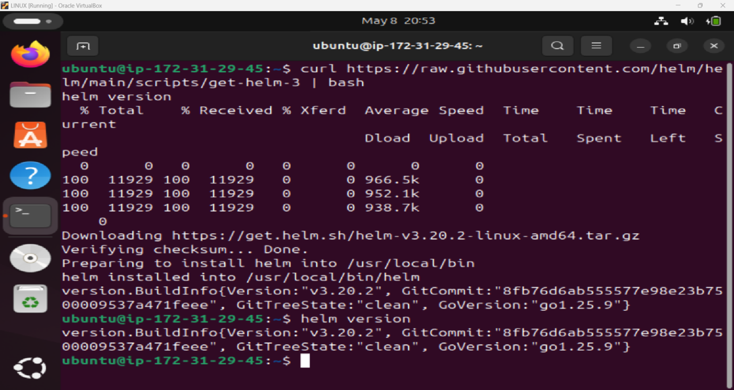

Add the Prometheus Community Repo:

helm repo add prometheus-community https://prometheus-community.github.io/helm-charts
helm repo update

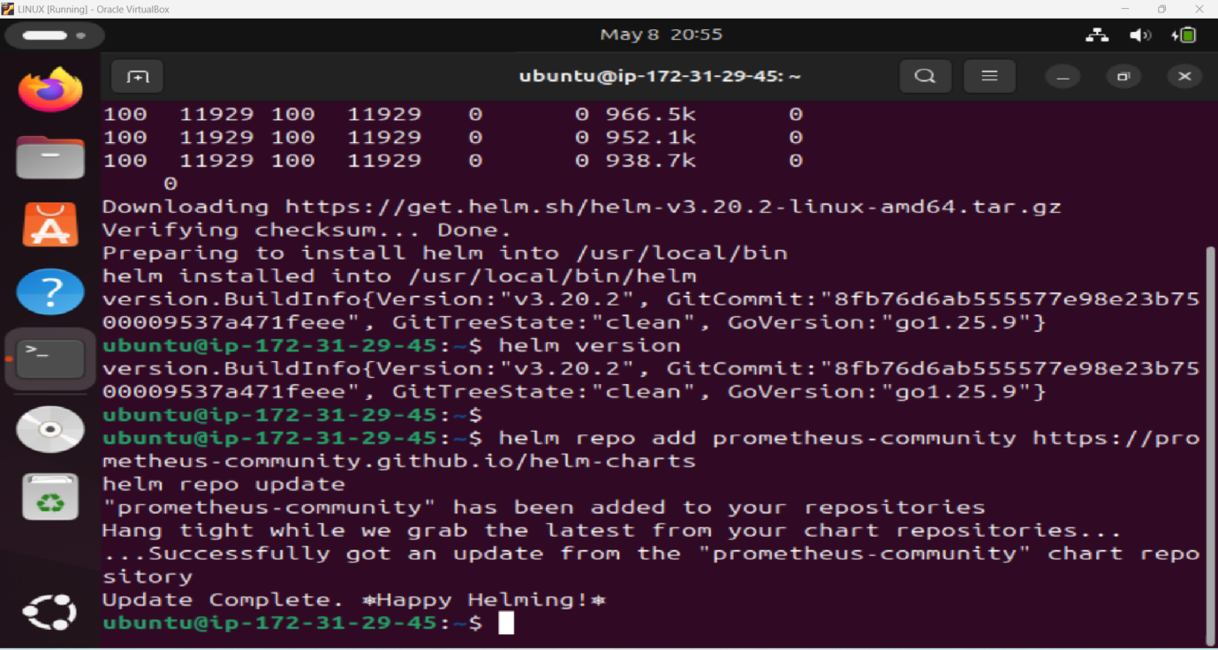

helm install monitoring prometheus-community/kube-prometheus-stack -n monitoring
kubectl get pods -n monitoring

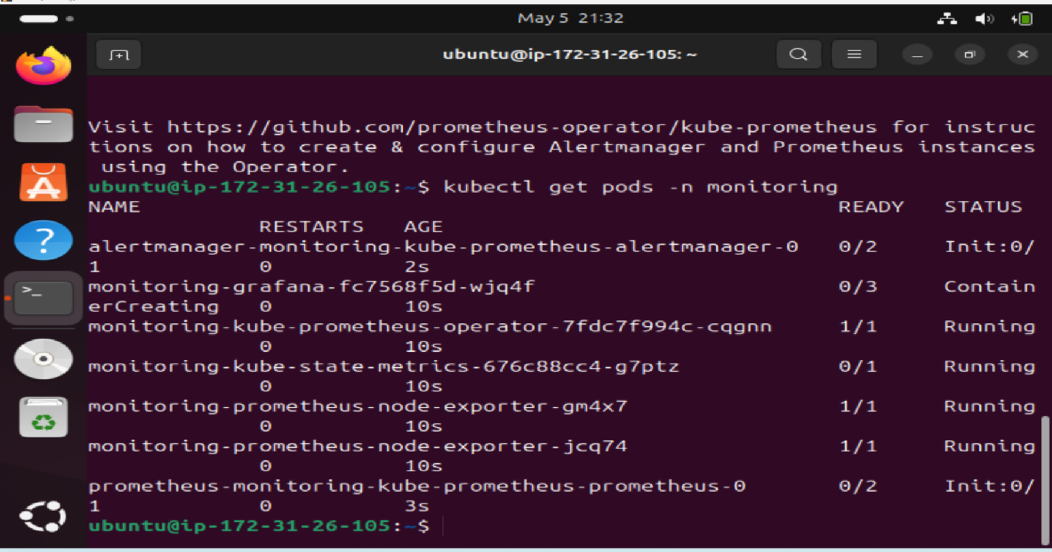

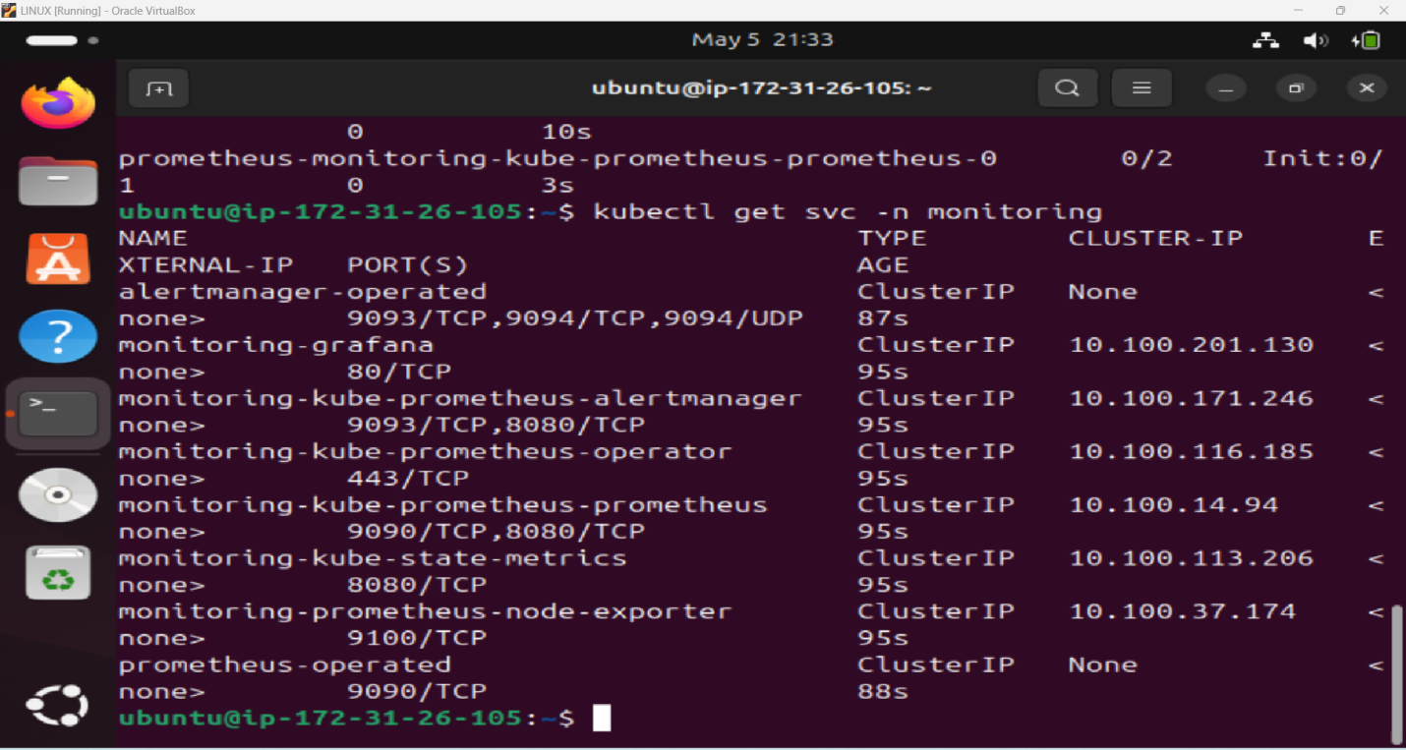

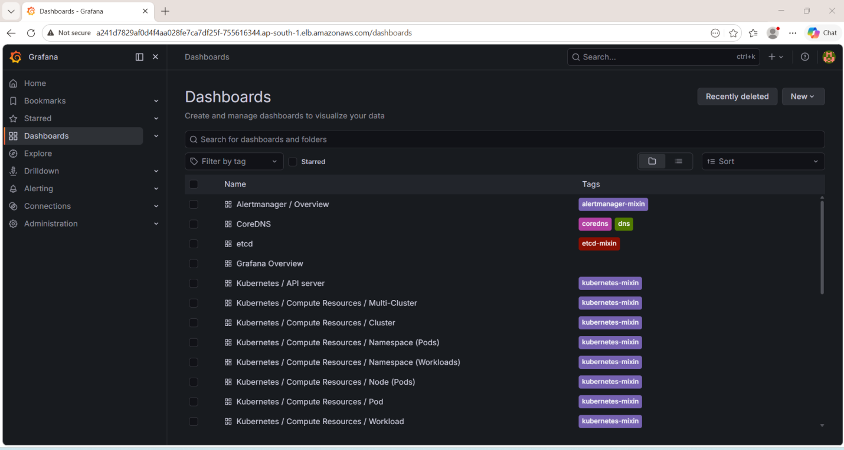

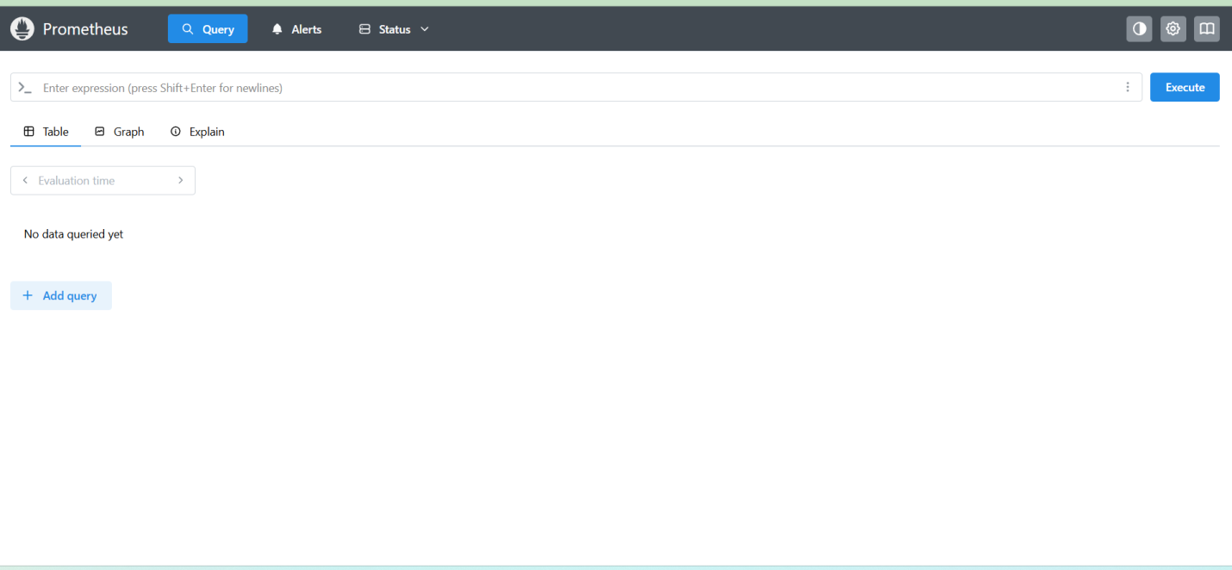

Kubernetes / Compute Resources / Pod:

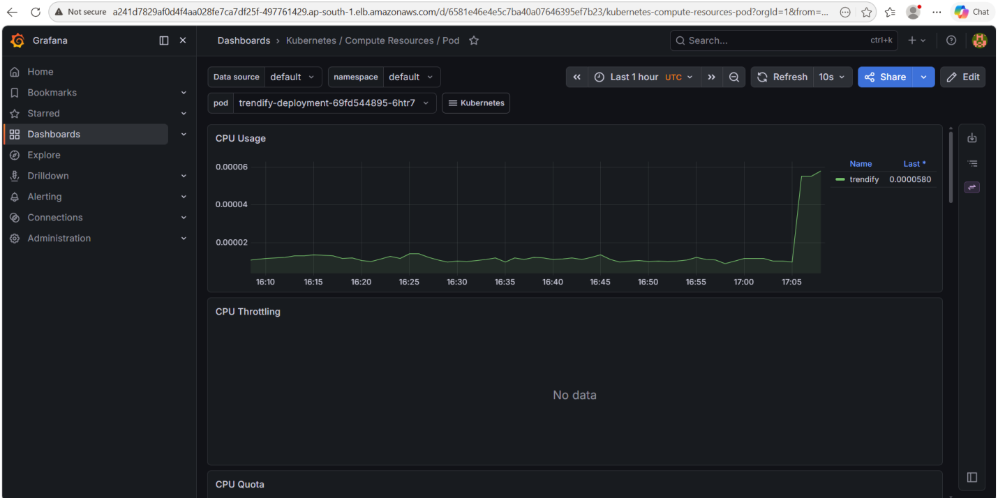

Kubernetes / Compute Resources / Namespace (Pods):
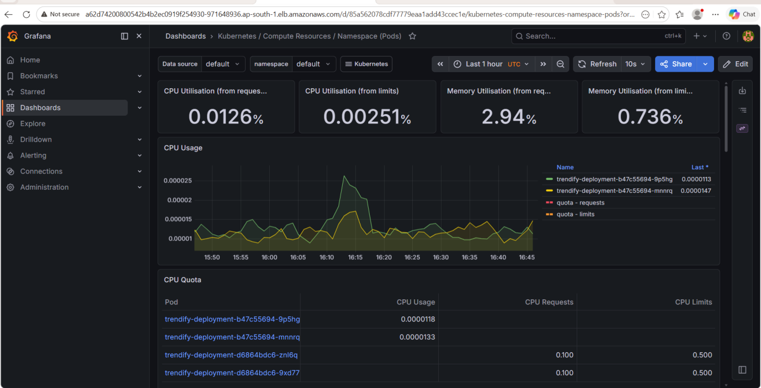

Kubernetes / Compute Resources / Cluster:
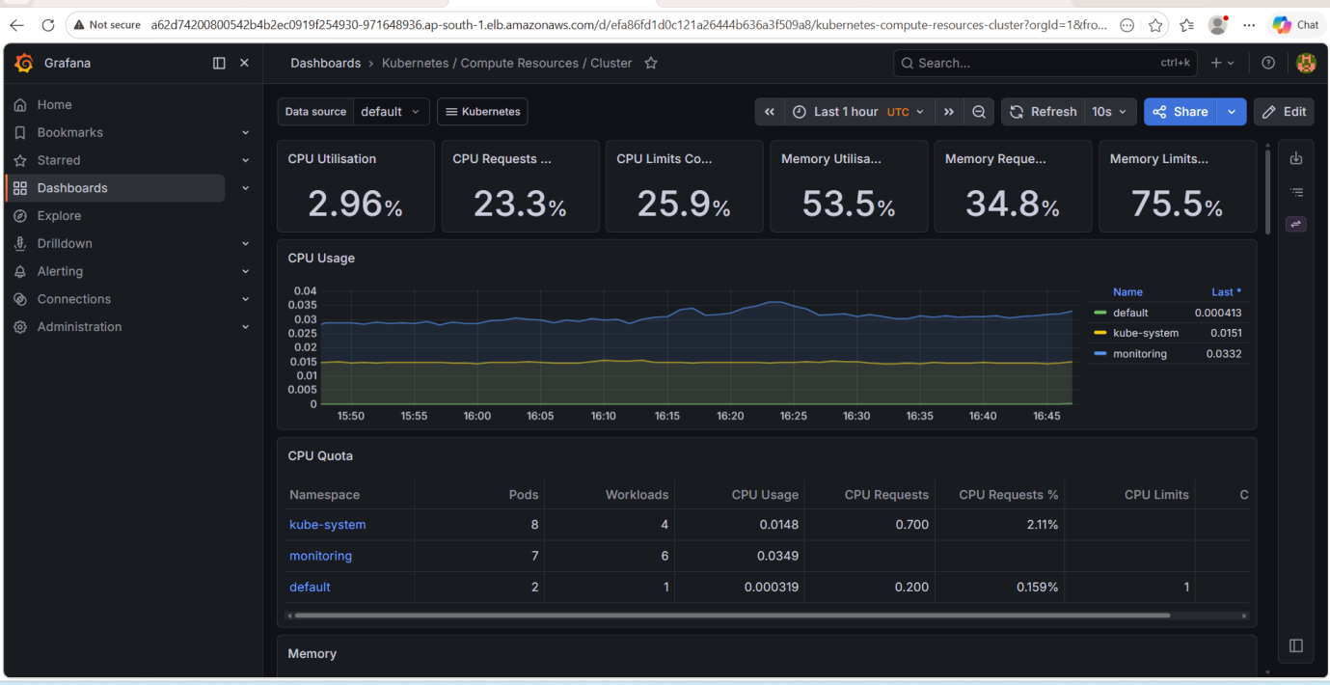

Kubernetes / Compute Resources / Namespace (Workloads):

